**Laravel Cashier (Stripe) Documentation**

**Task:**

**Stripe Charge**  
  
**Technology:  
1) Laravel Framework (used for 9)  
2) Laravel Cashier (Stripe)**

**3) npm**

**Task Abstract:**

1. Create a migration class for the products table with fields Name, Price, and Description.
2. Create a DB seeder class for product sample data (via DB seed).
3. List products in Grid view & for each product display name, price & 'Buy Now' button.
4. On clicking the buy now button redirect to a new page. Display the product detail with a Stripe credit card form on this new page.
5. When the Stripe credit card form is filled, make a charge for the selected product via Stripe using Laravel Cashier.

Step 1:

Create db in phpmyadmin

DB name : task;

Step 2

Migrate database table

Cmd:

->php artisan migrate

Step 3

DB seeder run

Cmd:

->php artisan db:seed --class=productseeder

Step 4

Run the programme open folder terminal

Cmd:

-> php artisan serve

Next open folder terminal

Cmd:

->npm run dev

Step 5

Open the Laravel application in web Browser

URL : http://127.0.0.1:8000/

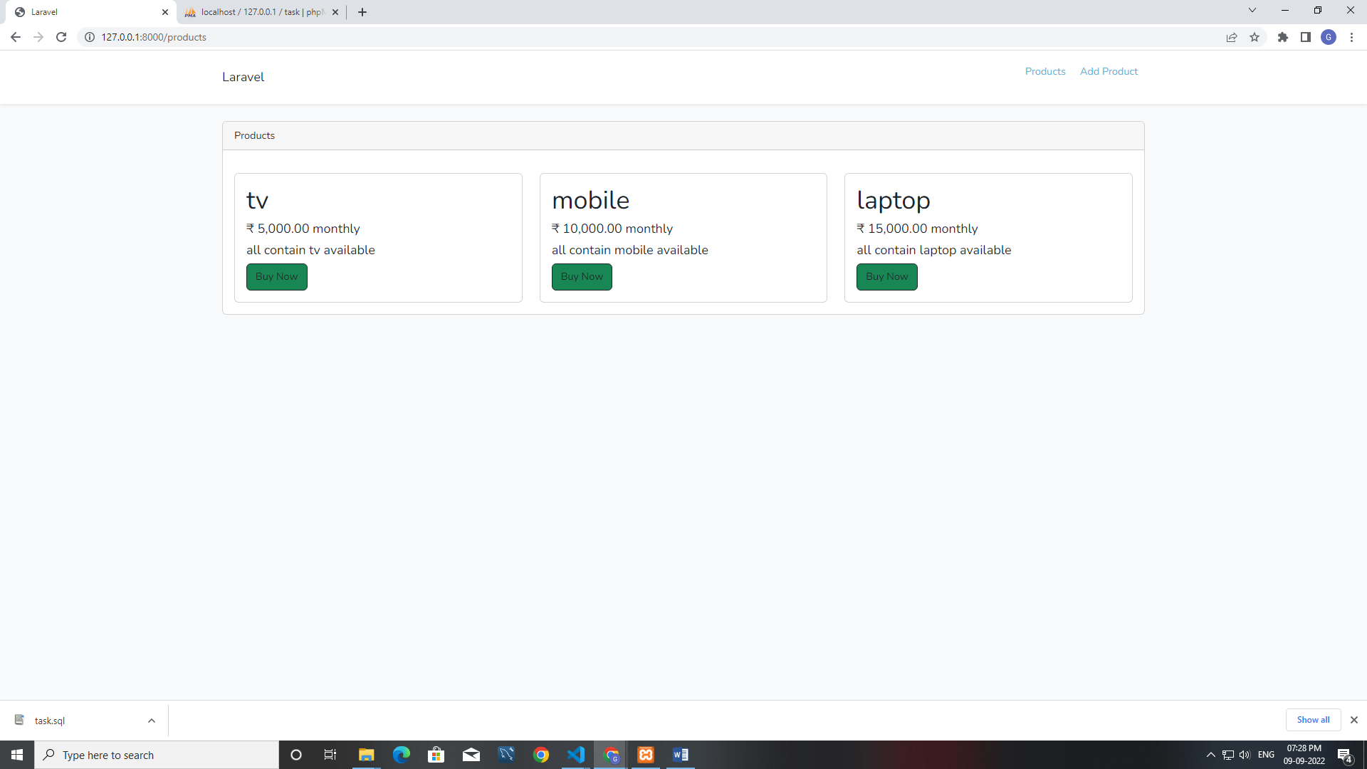

Step 6

BuyNow Product

* Click buynow open new window for payment getaway

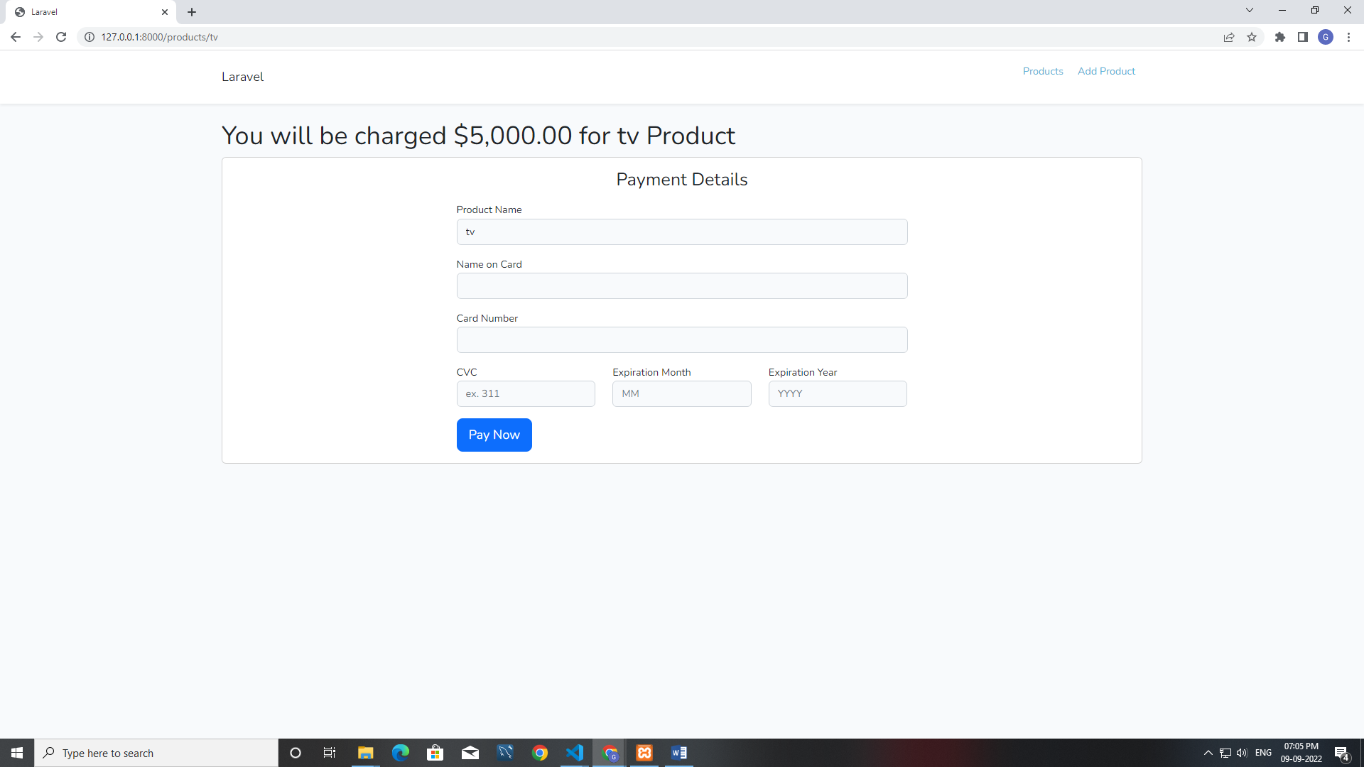

Test credit card details link

* <https://stripe.com/docs/testing>

Once input your card details. Transaction is success

Payment is done Successful window open

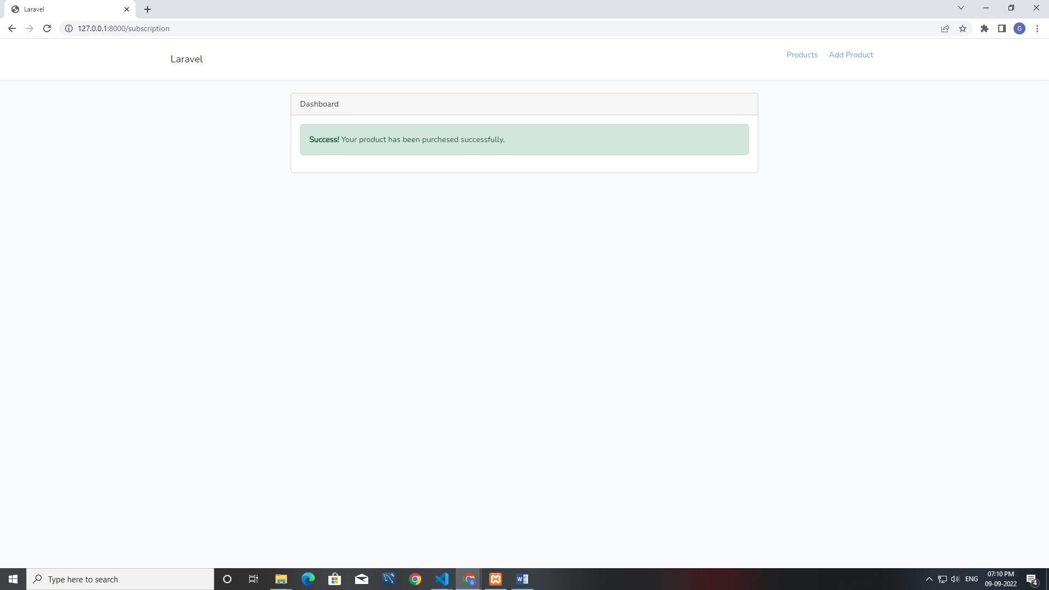

Payment is incorrect error window open

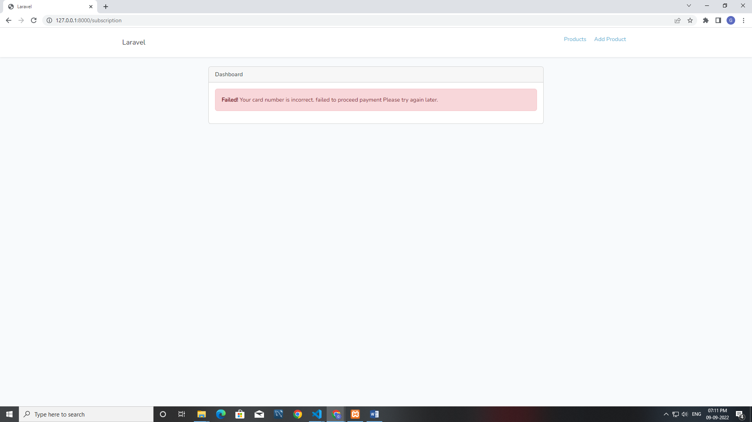

Validation error maintain for input fields

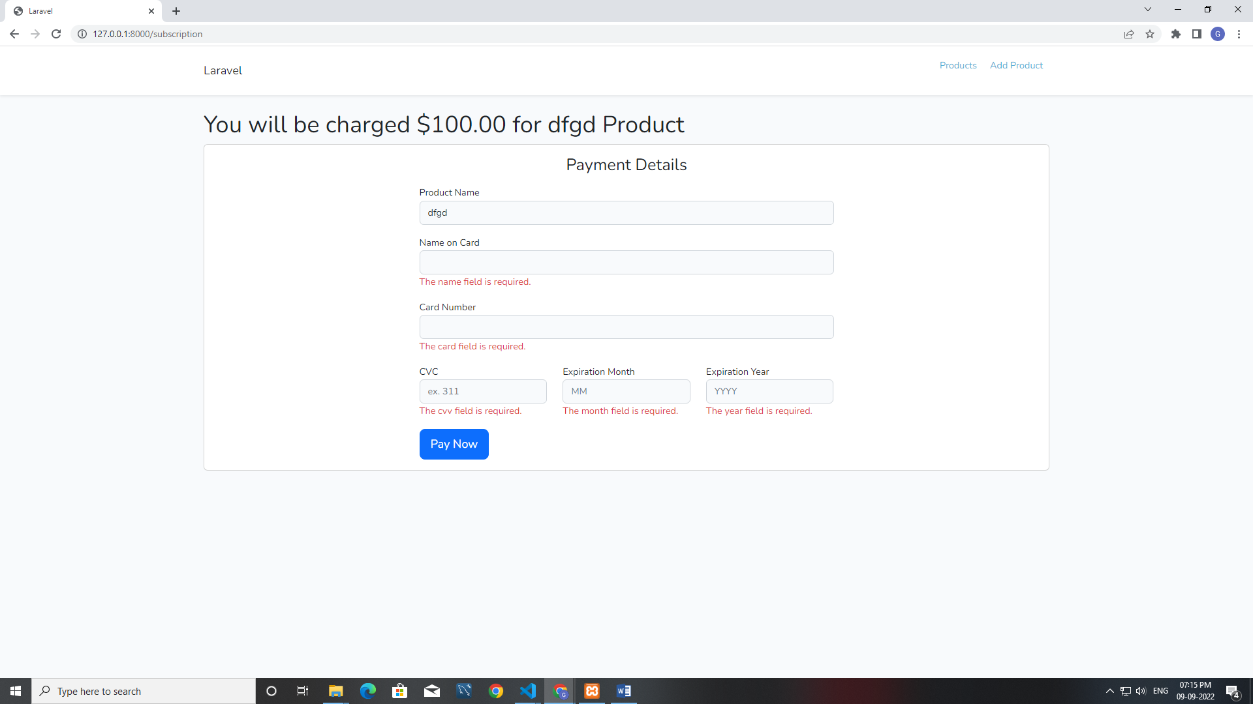

**Add New product**

* Go to the Navigation menu click Add product menu open new window for add new product.

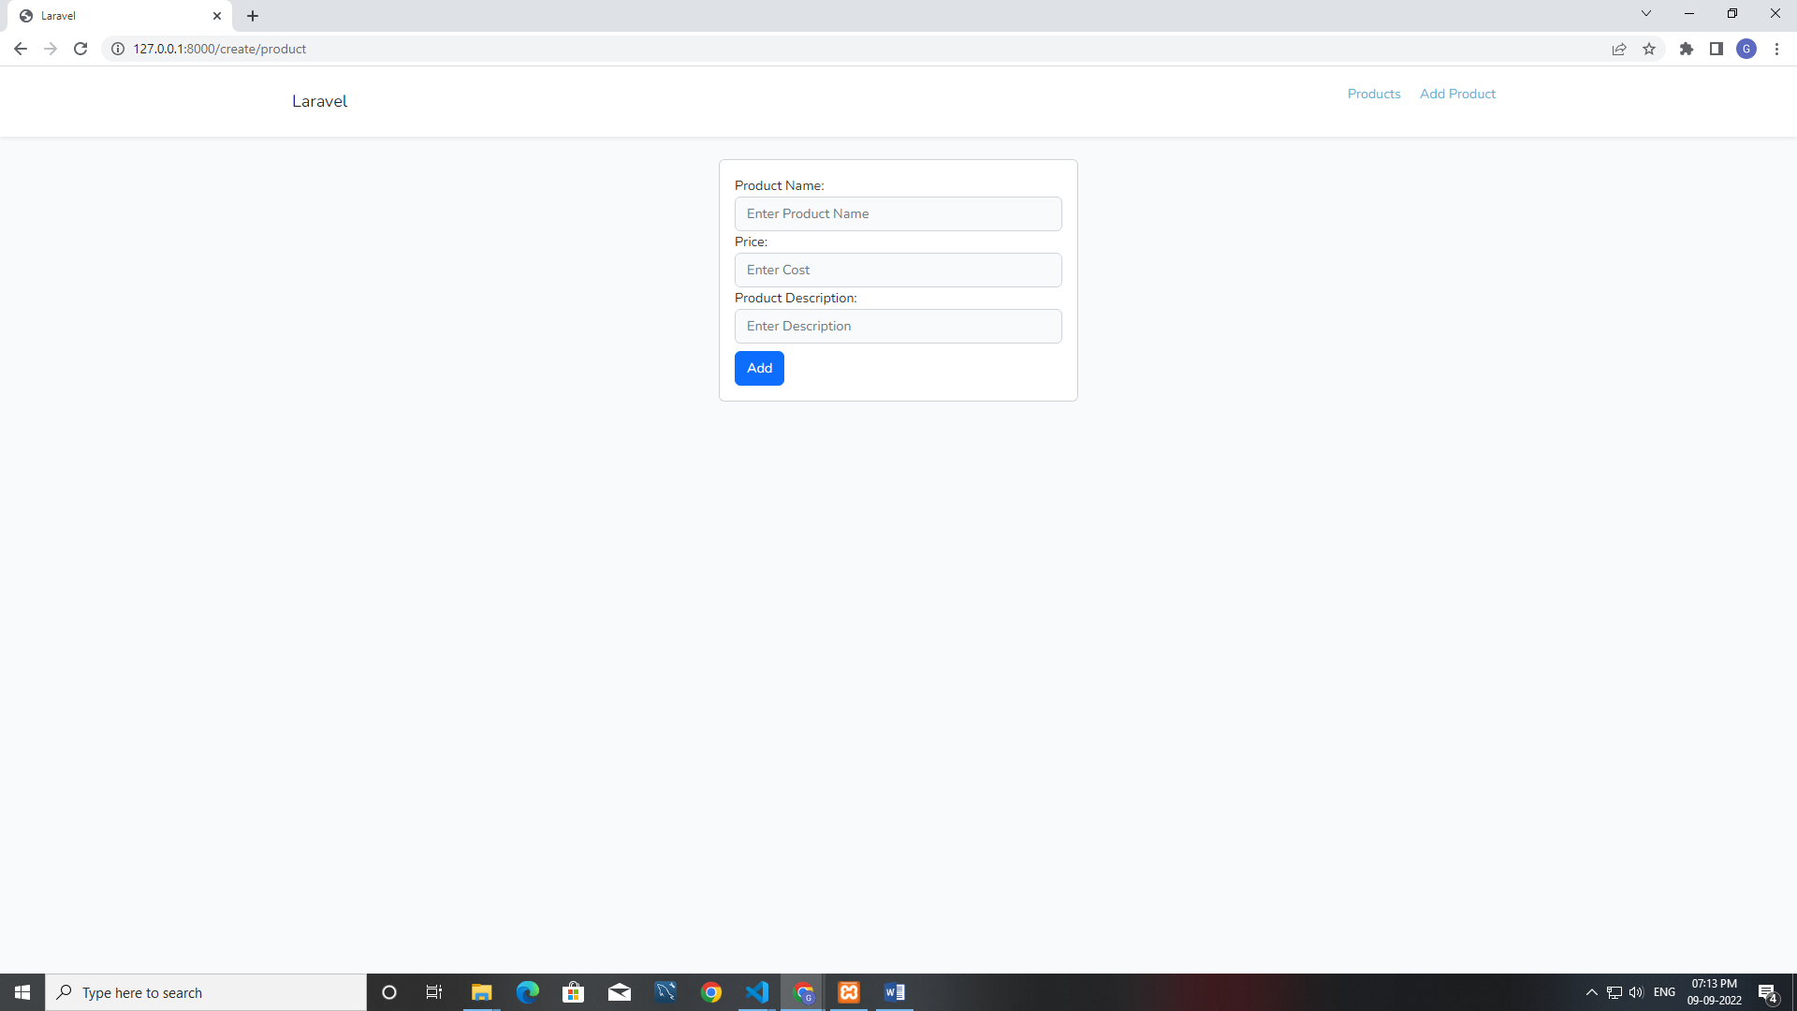

Fill the input fields add new product in your products list.

Go to the products page and buy a new products in your list.

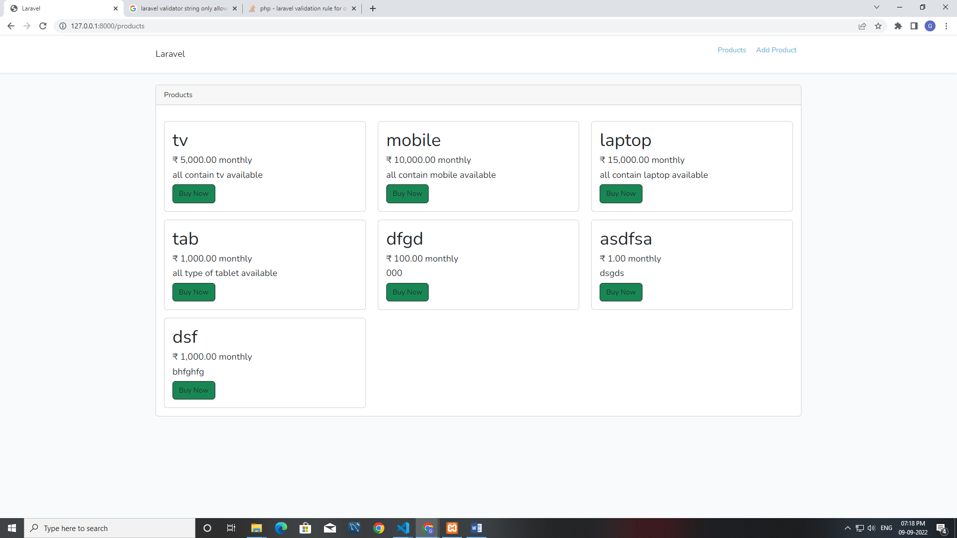

Validation error maintain for input fields

